Task 2 Mock Log

This is my base.html, here I made my navbar and I made it be inherited on every other page so the navbar is always there, I also made the logo clickable to take you back to the home page. I done this so you can go back to the home page from the logo as well as making it look nice and easy put it on every other page.



This is the home page/index. Again, each page inherits the navbar, I put the description that they gave me as well as 2 pictures for decoration.

This is the ouranimals.html. Here you can see that I put the styling in the html as that is what the tutorial did (referenced in the other document). The JS is also here as well. The website will display the first photo as well as it’s caption in a box and then have a next and back button which will display the corresponding photo with it’s caption.

The reason I made a photo gallery is too allow the user to scroll through each of the animals and read about them which might engage them. The business also asked me to do this.

Flask file for home and our animals.

This is where the database was made and inside the database there is a table called contacts for the contact form to be stored for the contact us page. I done this because I feel as if this is what the contacts table would need as fields.

Contact us form

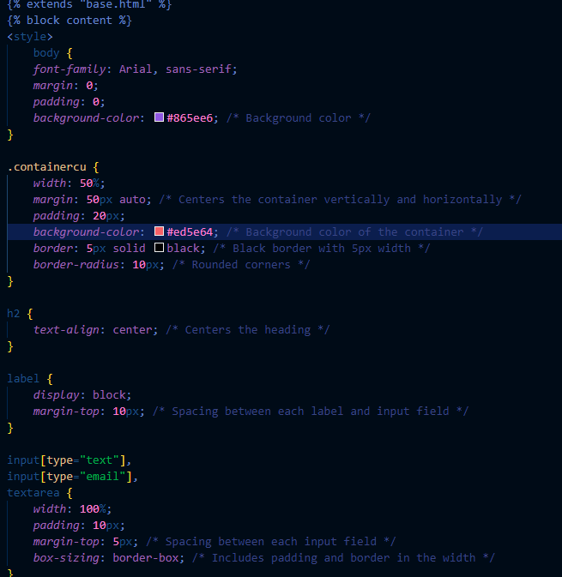

HTML and styling for contact form ; submit changes on hover, telephone has sample text.

Contact us database

Python flask file for the contact form. First it assigns each field to its respecting variable from the html. Then it makes sure that it is not left blank. It creates a connection with the DB then puts the data in the right fields in the table. If there is an error it will display it on the results page else it will display success on the html.

Result html that displays the result of form.

I added a results page to see what the outcome of the operation was and to give the user a confirmation that their request was put into the database or not.

Creating users db

2 snippets of login function, has a class as well to check against characteristics such as if its already logged in etc. If logged in it will send you to booking page, if details are not correct or do not exist it will ask you to log in again, registering and logout function work as well, as well as remember function. Code will also hash and use bcrypt etc to protect password.

The reason I made a class was too allow the logged in user to have attributes which I can pick from in the rest of the code e.g. is the user logged in. I have hashed the password for good security. I’ve also allowed the user to click on the remember box due to ease of access so they don’t have to log in every time. The login page will also give you feedback such as log in again if the details are incorrect.

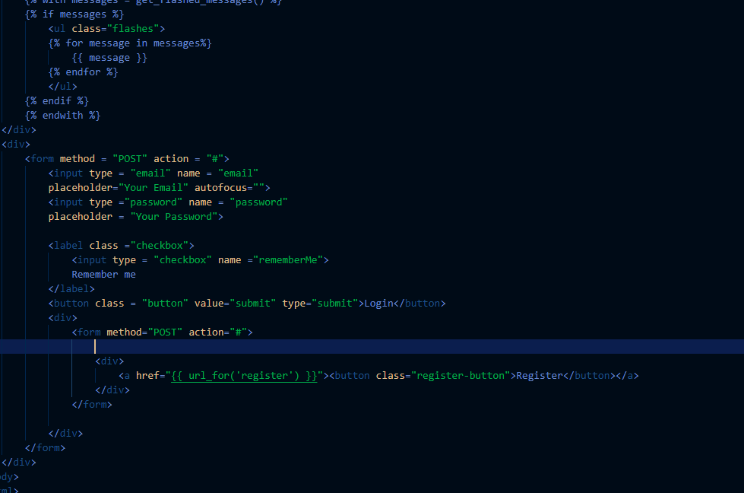

This is the html for my login page; currently the register button does not redirect you to the register page correctly. Currently there is no fix; putting /register at the end of the URL bar will take you to the register page where you can register properly.

Register HTML page.

I have also made a basic opening times page, if I had more time I would make a better time table right now it is bit basic.

Again, I have made a basic testimonials page; If I had more time I would allow the logged on users to enter a review into a database and then post it on the page instantly. I have kept it simple right now due to it being easy to be read and seen.